

Farm share and price spread in Australia's sugar supply chain

Breeana Sandley, Tim Goesch and Nga Nguyen

**Research by the Australian Bureau of Agricultural  
and Resource Economics and Sciences**

Research report 17.2

July 2017



© Commonwealth of Australia 2017

Ownership of intellectual property rights

Unless otherwise noted, copyright (and any other intellectual property rights, if any) in this publication is owned by the Commonwealth of Australia (referred to as the Commonwealth).

Creative Commons licence

All material in this publication is licensed under a Creative Commons Attribution 3.0 Australia Licence, save for content supplied by third parties, logos and the Commonwealth Coat of Arms.

by

Creative Commons Attribution 3.0 Australia Licence is a standard form licence agreement that allows you to copy, distribute, transmit and adapt this publication provided you attribute the work. A summary of the licence terms is available from [creativecommons.org/licenses/by/3.0/au/deed.en](http://creativecommons.org/licenses/by/3.0/au/deed.en). The full licence terms are available from [creativecommons.org/licenses/by/3.0/au/legalcode](http://creativecommons.org/licenses/by/3.0/au/legalcode).

Cataloguing data

Sandley, B, Goesch, T & Nguyen, N 2017, Farm share and price spread in Australia's sugar supply chain, ABARES research report 17.2, Canberra, July. CC BY 3.0.

ISSN 1447-8358

ISBN 978-1-74323-332-0

ABARES project 43434

Internet

Farm share and price spread in Australia’s sugar supply chain is available at [agriculture.gov.au/abares/publications](http://agriculture.gov.au/abares/publications)/publications.

Australian Bureau of Agricultural and Resource Economics and Sciences (ABARES)

Postal address GPO Box 858 Canberra ACT 2601

Switchboard +61 2 6272 3933

Email [info.abares@agriculture.gov.au](mailto:info.abares@agriculture.gov.au)

Web [agriculture.gov.au/abares](http://agriculture.gov.au/abares/)

Inquiries about the licence and any use of this document should be sent to [copyright@agriculture.gov.au](mailto:copyright@agriculture.gov.au).

The Australian Government acting through the Department of Agriculture and Water Resources, represented by the Australian Bureau of Agricultural and Resource Economics and Sciences, has exercised due care and skill in preparing and compiling the information and data in this publication. Notwithstanding, the Department of Agriculture and Water Resources, ABARES, its employees and advisers disclaim all liability, including for negligence and for any loss, damage, injury, expense or cost incurred by any person as a result of accessing, using or relying on information or data in this publication to the maximum extent permitted by law.

Acknowledgements

The authors thank Richard Green, Haydn Valle and David Mobsby for assistance in compiling the data, Neil Thompson and Ben Agbenyegah for reviewing earlier analysis and David Galeano and Peter Gooday for their comments on this report. The authors would also like to thank Warren Males from Canegrowers and Jim Crane and Dominic Nolan from the Australian Sugar Milling Council for their comments.

Contents

Summary 1

1 Introduction 3

2 Background 5

The Australian sugar industry 5

The sugar value chain 6

3 Data sources and limitations 11

4 Price movements 13

World prices of raw and refined sugar 13

Export price of raw sugar 14

Farmgate price of sugar cane 15

Retail price of refined sugar 16

Price indices 16

5 Farm share and price spread 18

Methodology 18

Farm share of retail price 19

Farm share of export price 20

Comments on farm share 20

Farm-to-retail price spread 21

Farm-to-export price spread 21

Comments on price spreads 22

Further research 22

References 24

Tables

Table 1 Mill (and mill owner), by growing region 7

Figures

Figure 1 Sugar value chain 6

Figure 2 Real prices of sugar and sugar cane, 1984–85 to 2014–15 13

Figure 3 Real sugar price indices, 1984–85 to 2014–15 17

Figure 4 Farm share of retail price, sugar, 1984–85 to 2014–15 19

Figure 5 Farm share of export price, sugar, 1988–89 to 2014–15 20

Figure 6 Farm-to-retail price spread, sugar, 1984–85 to 2014–15 21

Figure 7 Farm-to-export price spread, sugar, 1988–89 to 2014–15 22

Maps

Map 1 Sugar growing regions, mills, refineries and ports 5

Boxes

Box 1 Cane pricing 15

Summary

There is some concern that consolidation in some sectors of the food supply chain could lead to farmers receiving lower prices than in perfectly competitive markets. One relatively inexpensive monitoring option is to analyse trends in the shares farmers receive from the sale of retail and export products and in spreads between farm and retail prices and farm and export prices. An increase in price spread or a decrease in farm share could be an early indicator of competition issues in one or more sectors in a supply chain.

This study uses a case study approach to demonstrate the potential to estimate farm shares and price spreads in Australia using a relatively simple methodology developed by the United States Department of Agriculture Economic Research Service (USDA ERS). In this instance, the methodology has been applied to Australian sugar price data.

Currently, there is a debate about increasing consolidation in the sugar milling sector and the impact of millers marketing and exporting an increasing volume of raw sugar. Previously, this marketing had been largely the responsibility of Queensland Sugar Limited (QSL), a public not-for-profit company set up to deliver ‘optimal returns to sugar millers and cane growers’.

The Australian sugar industry produces raw and refined sugar from sugar cane. In 2014–15, it produced 4.6 million tonnes and exported 3.7 million tonnes of sugar (raw equivalent) (ABARES 2016). The industry makes a significant contribution to a number of local economies located between Grafton in northern New South Wales and Mossman in Far North Queensland.

The study demonstrates that data is available that allows an analysis of farm share and price spread for raw sugar exports and refined sugar sold at retail outlets. The analysis shows that trends in farm shares of retail and export prices were relatively flat between 1984–85 and 2014–15. So too were trends in farm-to-retail and farm-to-export price spreads. If it is assumed that the emergence of market power beyond the farm gate is likely to be reflected in changes in trends in farm share and price spread, then these results suggest that there has been no obvious change in market power within the sugar industry over this period.

This is not unexpected given that the voluntary contractual arrangements put in place for marketing raw sugar exports, following the abolition of the single desk in 2006, essentially mirror the regulatory arrangements that were in place prior to 2006.

An important recent development in the Australian sugar industry was a push by some mill owners to withdraw from current raw sugar marketing arrangements with QSL, and to market all of their raw sugar exports independently. Concern by some within the industry that this would deny growers choice in how the share of sugar for which they have price exposure is marketed led to the Sugar Industry Act 1999 being amended in late 2015 to allow cane growers to nominate who will market this sugar.

It remains to be seen whether recent changes to marketing arrangements will alter farm share or price spread in the sugar industry. Given the availability of suitable data, continued monitoring of farm share and price spread seems warranted. While changes in farm share or price spread are not definitive indicators of competition issues, this type of analysis could be used to trigger more detailed analysis if a significant change were to be observed.

There are several options for additional analysis. One option is to collect cost and price data beyond the farm gate. These data could allow an analysis that differentiates between sectors (for example, the milling and retail sectors), and identifies the range of factors influencing costs and prices within these sectors. It could also potentially facilitate the estimation of profit margins in different sectors, which is a major indicator of market power. A problem with this approach is that the data is commercially sensitive, and likely to be difficult to obtain. The detailed nature of this type of analysis also suggests that the approach is more likely to be suitable for one-off analysis after more aggregated analysis indicates further investigation is required, rather than as a tool for ongoing monitoring and evaluation. It may also be possible to improve the accuracy of estimates for farm share and price spread in the sugar industry through the use of better quality data, such as retail scanner data from supermarkets or homescan data from market research companies. This option may be worth pursing in any future analysis given that the ABS no longer publishes retail data on sugar prices.

# Introduction

There is a growing perception that consolidation in some sectors of the food supply chain means that farmers have little choice but to accept lower prices than in perfectly competitive markets. There are several options for investigating whether market power is an issue in food supply chains. One relatively inexpensive monitoring option is to analyse trends in the shares farmers receive from the sale of retail and export products and in spreads between farm and retail prices and farm and export prices. This study focuses on farm share and price spread in the sugar industry.

Farm share is the proportion farmers receive of the price of a product sold to customers while price spread is the difference between the sale price of a product and the price received by farmers. The farm-to-retail price spread includes payments for all services that add value to farm products beyond the farm gate to the point of sale to customers, including transporting, processing, storing and retailing.

A decrease in farm share or an increase in price spread may indicate imperfect price transmission. This can occur when there is a lack of competition in one or more sectors in the food supply chain. If some agents in the supply chain have more market power than others, they may be able to manipulate prices, which could lead to higher retail prices or lower farmgate prices. However, as noted in Nguyen, Mobsby & Goesch (2016), identifying inefficiency within food supply chains because of an increase in market power in one or more sectors is more complex than simply identifying an increase in price spread or a decrease in farm share. This is because these changes can occur for a number of reasons that are not related to market power.

In the sugar industry, cane growers are concerned that the market power of mill owners is increasing. Two reasons are usually given. The first is consolidation in the milling sector. There are currently 24 mills owned by 8 companies compared with 29 mills owned by 12 companies in 1997 (Breguet 2011). The second reason is that millers are marketing and exporting an increasing volume of raw sugar, where this used to be largely the responsibility of QSL. QSL is a public not-for-profit company set up to deliver ‘optimal returns to sugar millers and cane growers’.

Millers argue that consolidation is not a problem, and that growers do have leverage when dealing with mills as mill profitability requires high throughput, with millers highly dependent on growers continuing to supply their cane (Wilmar Sugar 2014). There is also a legal framework governing the negotiation of cane supply agreements between millers and growers. This framework includes provisions for collective bargaining and arbitration to resolve any commercial disputes. Finally, payment for sugar cane is underwritten by the cane payment formula, which allocates net income from sugar sales between growers and millers. According to the Australian Sugar Milling Council (ASMC), '… mills don't set the price for sugar cane; it is determined through the cane payment formula and set almost entirely by the global price of sugar' (ASMC 2015a).

Trends in farm share and price spread can potentially provide important information on efficiency in price transmission in the sugar supply chain. This research is timely given that cane growers and milling companies continue to debate issues of market power and what reforms to export marketing arrangements mean for the industry.

This paper is organised as follows. Chapter 2 contains background information on the Australian sugar industry, while Chapter 3 provides a description of the price data used in the analysis and some of its limitations. Some of the factors influencing sugar prices over the past 30 years are identified in Chapter 4. Chapter 5 describes the methodology used to calculate farm share and price spread and contains estimates based on this methodology using Australian farmgate, export and retail price data. It also identifies some options for additional research that could improve the analysis.

# Background

## The Australian sugar industry

The Australian sugar industry produces raw and refined sugar from sugar cane. Sugar cane is grown along Australia’s north-eastern coast, from Grafton in northern New South Wales to Mossman in Far North Queensland (see Map 1).

Map Sugar growing regions, mills, refineries and ports

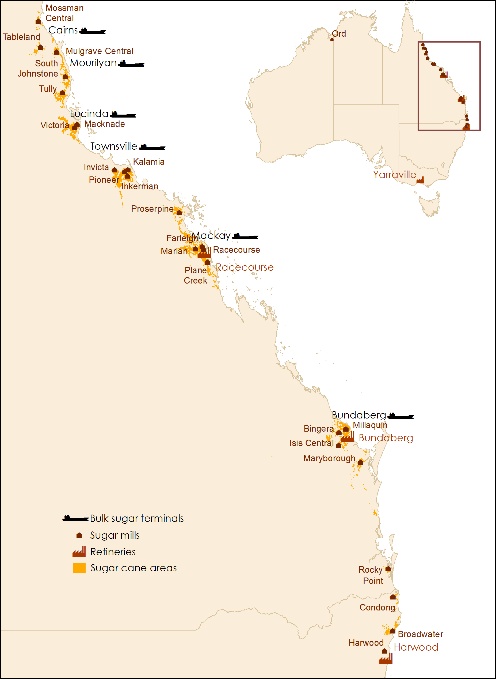

Note: The Ord sugar mill is no longer operational.

Source: ASMC 2015b, ABARES

In 2014–15 the gross value of sugar cane production was around $1.3 billion (or 2.4 per cent of the total value of Australian farm production), with 378,000 hectares of cane producing 4.6 million tonnes of raw sugar (ABARES 2015). Queensland typically produces around 95 per cent of this sugar, with the remaining 5 per cent produced in New South Wales.

Around 85 per cent of sugar produced in Queensland is exported (ASMC 2015b), while most sugar produced in New South Wales is consumed in the domestic market.

## The sugar value chain

The value chain is the process by which value is added to a product through activities such as transport, processing, storing and marketing (Figure 1). The major stages of value-add to sugar cane from farms are sugar milling and sugar refining. Value added through further processing and marketing of refined sugar are not included in Figure 1.

Figure Sugar value chain

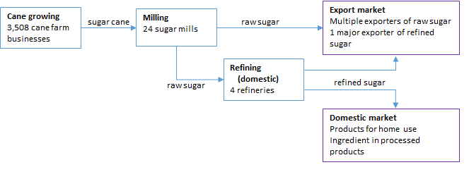

Source: Adapted from Spencer 2004

### Cane growing

In 2013–14 there were 3,508 sugar cane farm businesses in Australia with at least 5 hectares planted to sugar cane and an estimated gross value of production of at least $30,000 (Valle & Martin 2015). Sugar cane is typically harvested between June and December (drier months in the tropics) and delivered to mills by rail and/or road. Because cane sugar levels deteriorate over time, cane needs to be transported to mills and crushed (to extract the raw sugar) soon after harvest.

In Queensland, 93 per cent of cane harvested in the 2014 crushing season was transported directly to raw sugar mills on railways owned by mills, with the remainder moved by road or a combination of road and rail (ASMC 2015c). In New South Wales, sugar cane is transported to mills by road (Sunshine Sugar 2015).

### Sugar milling

Legal ownership of sugar cane passes from growers to millers when cane is delivered to a mill, as set out in Cane Supply Agreements (CSAs) (ASMC 2014). CSAs are agreements between growers and millers that set out terms and conditions for payment for cane. They also set out terms and conditions for harvesting, transporting, delivering and crushing cane. Most CSAs contain cane pricing formulas (see Box 1 for detail) that express cane prices as a function of net raw sugar prices and the sugar content of cane. The net raw sugar price is the price received by a mill for the sale of sugar produced from cane, and links the cane price to the world raw sugar price (Wilmar Sugar 2014). CSAs are required under the Sugar Industry Act 1999 (Qld).

Cane is usually crushed 6 to 14 hours after harvest (ASMC 2015c). Around 7.24 kilograms of sugar cane are required to produce one kilogram of raw sugar (although this can vary) (ABARES 2015). Valuable by-products are also produced in the milling process, including bagasse (fibre), molasses and mill mud. Bagasse and mill mud are re-used by industry whereas molasses is marketed separately.

There are currently 24 mills operating in Australia, all of which are located close to cane growing areas. Twenty one are in Queensland and three are in New South Wales (see Table 1). These mills are owned by eight companies, three of which are fully or partially grower owned. Around 75 per cent of Queensland's milling capacity is owned by foreign parent companies (ASMC 2014). The perishability of cane and transport costs effectively restrict growers’ choice of which mill to supply, although ASMC (2014) argues that the interdependence between growers and millers goes both ways, with millers reliant on high levels of throughput to generate profits.

Table Mill (and mill owner), by growing region

|  |  |  |  |  |
| --- | --- | --- | --- | --- |
| Northern | Herbert-Burdekin | Mackay-Proserpine | Southern | NSW |
| Mossman (Mackay Sugar Ltd)  Tablelands (MSF Sugar Ltd)  Mulgrave (MSF Sugar Ltd)  South Johnson (MSF Sugar Ltd)  Tully (Tully Sugar Ltd) | Macknade (Wilmar Sugar Ltd)  Victoria (Wilmar Sugar Ltd)  Invicta (Wilmar Sugar Ltd)  Pioneer (Wilmar Sugar Ltd)  Kalamia (Wilmar Sugar Ltd)  Inkerman (Wilmar Sugar Ltd) | Proserpine (Wilmar Sugar Ltd)  Farleigh (Mackay Sugar Ltd)  Marian (Mackay Sugar Ltd)  Racecourse (Mackay Sugar Ltd)  Plane Creek (Wilmar Sugar Ltd) | Bingara (Bundaberg Sugar Ltd)  Millaquin (Bundaberg Sugar Ltd)  Isis (Isis Central Sugar Mill Company Ltd)  Maryborough (MSF Sugar Ltd)  Rocky Point (WH Heck & Sons Pty Ltd) | Condong (Sunshine Sugar)  Broadwater (Sunshine Sugar)  Harwood (Sunshine Sugar) |

Source: Canegrowers 2010

After milling, most raw sugar is transported by rail (state or mill-owned) or road to bulk storage terminals for storage before being sold to Australian or overseas refineries. Raw sugar is also supplied directly to co-located domestic refineries or transported (by ship or road) to be processed into refined sugar and other sugar products including golden syrup, treacle and coffee sugar.

### Sugar refining

There are currently four refineries in Australia, two in Queensland and one each in New South Wales and Victoria. Sugar Australia Limited, which is 75 per cent owned by Wilmar and 25 per cent owned by Mackay Sugar, operates two refineries, one in Mackay (Queensland) and one in Yarraville (Victoria). The second Queensland refinery (in Bundaberg) is owned and operated by Bundaberg Sugar Limited. The New South Wales refinery (in Harwood) is operated by Sunshine Sugar, which is jointly owned by the NSW Sugar Milling Co-operative Ltd and the Manildra Group.

Most refined sugar produced in Australia is supplied to the domestic market. Refined sugar and other sugar products for domestic consumption are generally transported by road to retail distribution centres (packs for home use), or to manufacturers for use as an ingredient in a range of foods and beverages.

### Export market

Australia is a major sugar exporter (only Brazil and Thailand export more sugar), typically exporting over 70 per cent of its production (mostly as bulk raw sugar). In 2014–15 Australia exported 3.7 million tonnes of sugar (raw equivalent) valued at $1.6 billion (ABARES 2016). This is equivalent to 6.6 per cent of sugar traded worldwide. Brazil and Thailand accounted for 42 per cent and 15 per cent of world sugar exports (ABARES 2015).

The main markets for Australian sugar include the Republic of Korea, Indonesia, Japan, China, Malaysia, the United States and New Zealand (ABARES 2015).

Most raw sugar is stored at bulk sugar terminals before sale to Australian and overseas refineries. Raw sugar is exported from six ports (Bundaberg, Cairns, Lucinda, Mackay, Mourilyan, Townsville), with ports at Townsville and Mackay handling most bulk raw sugar exports. The Port of Mackay also handles a significant quantity of refined sugar (Queensland Transport and Logistics Council 2014). Bulk raw sugar terminals are owned by growers and milling companies via their shares in Sugar Terminals Limited. QSL sub-leases these terminals from Sugar Terminals Limited.

In Queensland, legal title for export sugar currently passes from the miller to QSL when sugar is delivered to a bulk sugar terminal. QSL markets raw sugar to international customers. It also provides pricing, risk management and financing services to growers and millers, as well as shipping and logistics services. Its primary goal is to deliver ‘optimal returns to sugar millers and cane growers’. Prior to 2006, QSL (and its predecessors) compulsorily acquired and marketed all raw sugar exports on behalf of the Queensland sugar industry. Following the removal of the single desk in 2006, QSL entered into voluntary contracts with most millers to market raw sugar. These contracts are referred to as Raw Sugar Supply Agreements (RSSAs) (QSL 2016). Under these contracts, mill owners contract to supply raw sugar to QSL.

In 2013 new RSSAs were negotiated allowing mill owners to market a proportion of the raw sugar they supply to QSL. This sugar is referred to as Supplier Economic Interest (SEI) sugar, and usually accounts for around one-third of the sugar millers supply to QSL, but can be as high as 50 per cent, depending on the Commercial Cane Sugar (CCS) content of cane and the quantity of sugar a mill produces from cane grown on company land. Where mill owners choose this option, QSL sells this sugar back to the miller for the miller to export. The remaining sugar supplied to QSL is Grower Economic Interest (GEI) sugar, and is currently marketed by QSL (ASMC 2014). QSL remains the dominant marketer of Australian sugar, selling 62 per cent of Queensland's raw sugar exports in 2014–15 (QSL 2015a). It is uncertain whether QSL will be the dominant marketer of Australian sugar after the commencement of the 2017 season.

In 2014 Wilmar Sugar Australia Limited, MSF Sugar Limited and Tully Sugar Limited notified their intention to withdraw from current sugar marketing arrangements with QSL when these agreements expire (in 2017–18), and to market all of their sugar independently. However, concern by some within the industry that these new marketing arrangements would deny growers’ choice in how GEI sugar was sold led to a private member’s Bill being introduced into the Queensland Parliament in May 2015. This Bill passed in late 2015, resulting in amendments to the Sugar Industry Act 1999 (see Sugar Industry (Real Choice in Marketing) Amendment Act 2015 (Qld)) allowing cane growers to nominate who will market GEI sugar.

According to a submission by Canegrowers and the Australian Cane Farmers Association (ACFA) to the Queensland Productivity Commission on the impact of the Sugar Industry (Real Choice in Marketing) Amendment Act 2015, the withdrawal of mills from existing marketing arrangements was a misuse of market power designed to ‘alter the way in which rewards and risks are shared across the industry in favour of the mill’ (Canegrowers & ACFA 2015).

However, the Queensland Productivity Commission found no evidence to support a case for market failure in the Queensland sugar industry that would indicate the need for additional government intervention:

The most likely impact of a no change scenario is that growers and millers will be no worse off, and with some millers pursuing models that could increase the returns to the sector. To the extent that these improvements increase raw sugar production and/or increase net premiums, these benefits are generally distributed to growers on a 2:1 ratio, consistent with the Cane Price Formula (Queensland Productivity Commission 2015 p. 84).

Similar to the Queensland Productivity Commission, the (Australian) Productivity Commission found 'no market failure or other reasonable objective to justify re-regulation of the Queensland sugar industry' in its report on regulation in Australian agriculture, and recommended that the Queensland Government repeal the amendments made by the Sugar Industry (Real Choice in Marketing) Amendment Act 2015 (Productivity Commission 2016).

In early April 2017, the Australian Government registered a code of conduct for the sugar industry (Competition and Consumer (Industry Code—Sugar) Regulations 2017). The purpose of the code is to regulate the conduct of growers, mill owners and marketers (of GEI sugar) in relation to contracts or agreements for the supply of cane or the on‑supply of sugar. This includes establishing a process for pre‑contractual arbitration where the parties fail to agree to terms of contracts or agreements.

In addition, the regulations ensure that supply contracts between growers and mill owners have the effect of guaranteeing a grower’s choice of the marketing entity used to sell GEI sugar.

Wilmar, MSF Sugar and Tully Sugar have developed cane supply agreements compliant with the new laws. While MSF Sugar and Tully Sugar have agreed to a new CSAs with growers, negotiations between Wilmar and QSL over the marketing of GEI sugar have been protracted, thus delaying finalisation of CSAs. At the time of publishing, Wilmar and QSL had concluded an agreement on the marketing of GEI sugar, and growers were signing CSAs allowing them to choose the marketing entity to sell GEI sugar.

Despite changes to the Sugar Industry Act, uncertainty in the industry continues, as parties continue to debate issues of market power, sugar ownership and fairness.

### Domestic market

The domestic market for sugar is supplied by producers in Queensland and New South Wales. While most sugar produced in New South Wales is for domestic consumption, typically only around 15 per cent of Queensland’s raw sugar production is consumed domestically (ASMC 2015b).

The food and beverage manufacturing industry is the major user of sugar domestically and an important stage for value-adding. Around 78 per cent of raw sugar produced for the domestic market ends up (after being refined) in a wide range of products, including soft drinks, alcoholic beverages, confectionery and other processed foods. A relatively small quantity of raw and refined sugar products are imported for use by the manufacturing industry (BITRE 2015).

The other 22 per cent of raw sugar produced for the domestic market is used to produce refined sugar and other sugar products that are packaged for retail sale (mainly in supermarkets) or sold to the food service industry (generally in larger packs). There is some evidence to suggest that demand for retail packs has declined over time due to competition from alternative sweeteners, reduced at-home use and increased consumer health concerns (Spencer 2004).

# Data sources and limitations

Time series data on farmgate, export and retail prices are needed to investigate long-term trends in farm share and price spread. This chapter provides a description of the data used in this study, as well as some of its limitations. Despite the limitations of existing data, time series for these variables were compiled and used to examine movements in sugar prices over time.

Retail price is the price consumers pay for a food item in a retail store. The average annual retail price (by financial year) of refined sugar is calculated using data from the Australian Bureau of Statistics (ABS) Average Retail Prices of Selected Items (cat. no. 6403.0 before September 2004, cat. no. 6403.0.55.001 from December 2004). Quarterly retail price data for 2-kilogram bags of refined sugar are available from March 1978 until 2010–11. Prices are averages across a range of grades, qualities, brands and retailers in capital cities in Australia. These quarterly data are averaged to produce annual price estimates, and divided by two to obtain a per kilogram price. The ABS discontinued this price series in June 2011. In this study, data from the ABS Consumer Price Index (CPI) ‘Other food’ subgroup is used to extrapolate retail prices to 2014–15.

Farmgate price is the price farmers receive for their product, in this case sugar cane. The local unit value (by financial year) of sugar cane is used as a proxy for the farmgate price of sugar cane in this study. This is calculated by dividing the local value of sugar cane by the volume of production. Annual local value data for sugar cane is obtained from ABS Value of Agricultural Commodities Produced, Australia (cat. no. 7503.0) while annual volume of production data is obtained from ABS Agricultural Commodities, Australia (cat. no. 7121.0). Local unit value is calculated for production during the year (or season) irrespective of when payments are made. The ABS collect the data needed to derive local unit values via a survey sent to mills. Among other things, this survey asks millers how many tonnes of sugar cane were delivered for crushing and the payment made to growers for this cane. Local unit values exclude transport costs.

Export price is the price received for raw sugar that is exported. Bulk raw sugar is Australia’s major sugar export product (accounting for over 95 per cent of total sugar exports by volume in 2014–15). The export unit value (by financial year) of raw sugar is used as a proxy for the export price of raw sugar in this study. It is calculated by dividing the value of bulk raw sugar exports by the volume of bulk raw sugar exports. Annual estimates are derived by averaging quarterly data, available from 1988–89 until 2014–15. The data used to calculate this series is from ABS International Trade, Australia (cat. no. 5465.0) (ABS 2015). The ABS collect export data from export declaration forms submitted to the Department of Immigration and Border Protection (DIBP). The value is the market value of goods including domestic transport and insurance costs but excluding international transport and insurance costs.

The world price of raw sugar is calculated using data from the New York Board of Trade (2006) made available by the USDA ERS (USDA ERS 2016a). Up until 1987–88 this price is the average of monthly averages of Intercontinental Exchange (ICE) spot prices for bulk sugar, free on board, stowed at Caribbean ports. From 1988–89 it is the Intercontinental Exchange (ICE) nearby futures no.11 contract price, which is considered most reflective of the freely traded world raw sugar price (Butcher 2012). This price is usually expressed in US cents a pound, and has been converted into Australian dollars a kilogram using exchange rate data from the Reserve Bank of Australia.

The world price of refined sugar is also calculated using data from the New York Board of Trade (USDA ERS 2016a). Up until 2005–06 this price is the annual average of monthly prices for the no. 407 contract, London spot price, free on board Europe. From 2006–07 the price is the annual average of monthly futures prices for this contract.

All price series data have been adjusted for inflation using the ABS Consumer Price Index (cat. no. 6401.0) to allow an analysis of trends in real prices.

The price series created from these data sources provide a useful indication of price trends. However, there are some limitations:

* Annual price series data are aggregated from either monthly or quarterly data, which may result in some loss of information and variation.
* Data may not have been collected with the intention of creating a time series. For example, the specification and quality of items may have changed over time (ABS 2011a). Nonetheless, the general trends in the data should remain valid.
* The price of 1-kilogram of retail sugar is assumed to be exactly half of the 2-kilogram price reported by the ABS. While this may mean that prices in the retail series are lower than the actual cost of a 1-kilogram pack of sugar because of additional costs in packaging and handling 1-kilogram packs, the trend in the data should still be valid.
* The ABS CPI ‘Other food’ subgroup used to extrapolate retail prices after 2010–11 is not specific to sugar. While this subcategory includes sugar, it also includes eggs, spreads, food additives and condiments, oils and fats, snacks and confectionery and a sub-category referred to as other food products not elsewhere classified  (ABS 2011b). While some of these other foods are likely to have a high sugar content, others are likely to contain little or no added sugar.
* Farmgate and export prices are approximated by unit values. Again, while this may mean that absolute prices are not completely accurate, trends in the data series should be valid.

# Price movements

Figure 2 shows movements in real prices of sugar and sugar cane between 1984–85 and 2014–15. This figure shows that Australian sugar prices are correlated with movements in world sugar prices. There are several reasons why this is the case. First, Australia is heavily exposed to the world market, exporting over 70 per cent of its raw sugar. Second, the Australian sugar industry is one of the least protected in the world. Third, the domestic market is small compared to Australia’s production, and fourth, sugar produced in Australia only accounts for around 2.5 per cent of world sugar production, or 6.6 per cent of total world exports.

## World prices of raw and refined sugar

There are significant price distortions in the world sugar market, with less than 50 per cent of world sugar trade occurring in a free market (ICE Futures U.S. 2012). Trade distorting policies (such as quotas, floor prices and tariffs) designed to protect domestic industry remain in place in the European Union and other sugar producing countries, including the United States. There are also a range of preferential trade agreements in place. For example, the Korea-Australia Free Trade Agreement (KAFTA) reduced tariffs and the Japan-Australia Economic Partnership Agreement (JAEPA) recently reduced levies on Australian sugar (Trade & Investment Queensland Australia 2015).

Figure 2 shows world prices for raw and refined sugar using data that is most reflective of freely traded sugar. This data shows that the price of refined sugar is higher than the price of raw sugar, that these prices closely track each other and that there is no clear trend between 1984–85 and 2014–15. The average world price of raw sugar for this period was 28.9 cents a kilogram (in 2014–15 dollars), while the average world price of refined sugar was 38.2 cents a kilogram. Raw and refined world sugar prices were highest in 2010–11 (63.1 cents a kilogram and 74 cents a kilogram) and lowest in 2001–02 (11.1 cents a kilogram and 18 cents a kilogram).

Figure Real prices of sugar and sugar cane, 1984–85 to 2014–15

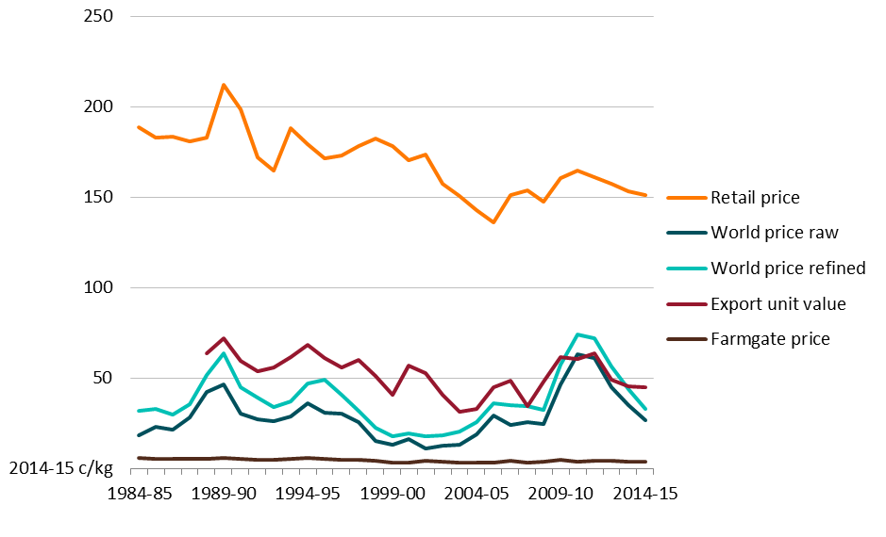

Source: Australian Bureau of Statistics (ABS), Average Retail Prices of Selected Items, cat. no. 6403.0 before Sep 2004, cat. no. 6403.0.55.001 from Dec 2004, Canberra; ABS Value of Agricultural Commodities Produced, Australia, cat. no. 7503.0, Canberra; ABS Agricultural Commodities, Australia, cat. no. 7121.0, Canberra; ABS International Trade, Australia, cat. no. 5465.0, Canberra; USDA ERS (2016) Sugar and Sweeteners Yearbook Tables, compiled from New York Board of Trade data

While it is difficult to identify any overall trend, there have been some significant movements in world sugar prices over the past 30 years. As with other commodities, the main determinants of world sugar prices are supply and demand, although changes in supply tend to be more important as world demand for sugar is relatively stable and inelastic (Butcher 2012). Small changes in sugar supplies can lead to significant changes to world sugar prices (Industry Commission 1992).

The peak in world sugar prices in 1989–90 coincided with the running down of stocks built up in the early 1980s, with world consumption exceeding production between 1986 and 1989. There was also a poor crop in the United States in 1990, which led to an increase in US sugar imports (Hannah & Spence 1997). The peak in 2010–11 coincided with significant disruptions to world production in 2008–09 and 2009–10, including unfavourable weather in Australia, Europe and North America, and infrastructure constraints impeding production in Brazil during the harvest season.

The trough in world prices in 2001–02 followed a period of relatively weak growth in demand for sugar and an expansion in Brazilian sugar exports—from 5.5 million tonnes in 1995–96 to 11.3 million tonnes in 2001–02 (ABARE 2003). The gradual recovery in prices that followed occurred as Brazil diverted a higher proportion of sugar cane to ethanol production (ABARE 2006) and as EU member states reduced production in response to a reduction in the EU’s sugar export subsidy programme (ABARE 2007).

While the world price of sugar is influenced by many factors, a critical supply side factor is the amount of sugar exported by Brazil each year. Because Brazil is a dominant producer and trader in the world market (it accounted for 42 per cent of the total volume of sugar traded in 2014–15 (ABARES 2015)), the amount of raw sugar it produces affects world prices (New York Board of Trade 2006). Factors that affect Brazil’s sugar production include disruptions to supply (for example, unfavourable climatic conditions or pests and disease), the exchange rate and ethanol prices. When ethanol prices are high the quantity of Brazilian sugar cane diverted to sugar production decreases. The increase in oil prices in the mid 2000s created an incentive for Brazil to divert cane to ethanol production.

## Export price of raw sugar

The real Australian export price of raw sugar averaged 52.5 cents a kilogram between 1988–89 and 2014–15, reaching a high of 71.7 cents a kilogram in 1989–90 and a low of 31.3 cents a kilogram in 2003–04. There is also a slight downward trend in the export price over this period. The export unit value closely follows movements in world sugar prices.

In addition, the export price of raw sugar tends to track above the world raw sugar price. Sometimes, as in the early 2000s, this price differential is significant, although the gap has narrowed in recent years. This premium includes several components. The freight component is determined by the location of the supplier and customer for raw sugar, and the location of the next potential supplier (ASMC 2015d). The main destinations for Australian sugar are the Republic of Korea, Indonesia, Japan and China. Australia has a significant shipping time advantage when exporting to these countries compared to some other countries, including Brazil (Goesch et al. 2015). Australian raw sugar may also attract a premium because of its quality and reliability of supply. In particular, the degree of polarisation (a measure of the sucrose content of sugar) of Australian sugar is generally higher than the standard quality specification set by the Sugar Association of London for the ICE no. 11 contract (96 degrees polarisation) (ASMC 2014).

## Farmgate price of sugar cane

The real farmgate price of sugar cane (as estimated by local unit value) averaged 4.5 cents a kilogram between 1984–85 and 2014–15 (Figure 2), and ranged between 6.0 cents a kilogram in 1989–90 and 3.0 cents a kilogram in 2003–04.

Cane pricing formulas are used to determine the price growers receive for sugar cane. These formulas link the price of cane to the world price of raw sugar and the CCS content of cane, which is a measure of the quality of cane (see Box 1 for further detail). The quality of sugar cane can be negatively affected by pests, disease and adverse weather, including drought, cyclones and heavy rain during harvest.

Box Cane pricing

|  |
| --- |
| Most CSAs contain cane pricing formulas (see below) that express cane price as a function of the net raw sugar price and the sugar content of the cane. Although these formulas are not required by legislation they have been used to determine cane prices for many years and have widespread industry support. CSAs may also include provisions that allow growers to share in the value of by-products such as molasses (Canegrowers 2010).  Pc = 0.009 × (CCS – 4) × Ps + Constant  Where:  Pc = cane price ($/tonne)  Ps = net raw sugar price ($/tonne sugar) (see below)  CCS = Commercial Cane Sugar, a measure of the recoverable sucrose in the cane (units)  The CCS is a measure of sugar cane quality. It estimates the level of extractable sucrose minus a negative weighting based on the impurities in the cane (ash, dirt etc) (Albertson & Grof 2004).  The net raw sugar price (Ps, the price received by the mill for the sale of sugar produced from that cane) links the cane price to the world price of sugar (Wilmar Sugar 2014). The ICE futures no. 11 contract price (world raw sugar price) accounts for around 99 per cent of the net sugar price.  Ps = ICE no. 11 price + Marketing Premiums – Marketing Costs  Where:  Ps = net raw sugar price ($/tonne)  ICE no. 11 price = Intercontinental Exchange, nearby futures, no. 11 contract price, converted to Australian dollars.  Marketing Premiums = additional components of price negotiated between parties to a sugar sales contract over and above the ICE no. 11 price converted to Australian dollars.  Marketing Costs = the costs associated with storing and handling sugar in the bulk sugar terminals, financing the industry advance payment scheme, administration of pricing and physical sales (note, marketing costs not only include futures brokerage but also include costs for unwinding forward pricing and sales if these tonnages are not received (QSL 2015b)). |

Source: Wilmar Sugar 2014

While cane prices generally move in line with world sugar prices, cane prices are insulated from variability in world prices to some extent through the use of risk management practices such as pooling and futures pricing (QSL 2013). Mechanisms enabling growers and millers to manage their price exposure independently of one another have been progressively introduced since the late 1990s (Warren Males [Canegrowers] 2015, pers. comm., 22 December). QSL offer a range of pooling options that allow growers to manage up to 70 per cent of their exposure to the world sugar price by allocating their production across a number of pricing pools, each with their own pricing and risk characteristics, and volume obligations (ASMC 2014). It is important to note, however, that the terms of the CSA between growers and the milling company they supply determines the extent to which growers can participate in this system.

Despite farmgate prices being highly correlated with world prices and Australian export prices, there have been instances where these price trends diverged in the short term (for example, in 2000–01 and 2010–11). There are several factors that can lead to a short-term divergence in trend. One factor is bad weather, which can affect the quantity and quality of sugar cane produced. Another factor is that most raw sugar is priced and sold forward, while the invoice value for exports largely reflects market conditions at the time futures positions are closed. This means that in a rising or falling market, the futures price locked in prior to the actual supply of cane can lag the spot market (for which the nearby ICE no. 11 contract is a proxy) (Warren Males [Canegrowers] 2016, pers. comm., 4 May). This may have contributed to the short-term deviation in farmgate and export price trends in 2000–01.

## Retail price of refined sugar

The real retail price of refined sugar averaged 169.4 cents a kilogram between 1984–85 and 2014–15. Prices were highest in 1989–90, at 211.9 cents a kilogram, and lowest in 2005–06, at 136 cents a kilogram. In 2014–15, the retail price of refined sugar was 151.2 cents a kilogram.

The retail price has trended down slightly over the past 30 years, and in major supermarkets the price of private label refined sugar can be as low as $1 a kilogram. An important driver of this trend has been the progressive deregulation of the Australian sugar industry. Deregulation began in 1989 with removal of the long-standing import embargo on raw and refined sugar (to be replaced with a tariff which was phased out over the 1990s) and the elimination of the government set price for domestic raw and refined sugar. There has been a narrowing of the gap between the retail price of refined sugar in Australia and the world price of refined sugar since deregulation (Industry Commission 1992). Of course, the retail price of refined sugar remains well above the world price, with distribution costs such as rent, labour, advertising and profits making up the difference.

Competition from alternative sweeteners, increased consumer health concerns and reduced at-home use may have also contributed to the declining trend in the retail price of sugar (Spencer 2004).

## Price indices

In order to more easily identify trends in sugar prices and to examine their movements relative to one another, the real price data underlying Figure 2 have been converted into price indices using 1990–91 as the base year (that is, all series are set to 100 in 1990–91) (Figure 3). These price indices show slight downward trends in the farmgate price of sugar cane, the export unit value of raw sugar and the retail price of refined sugar between 1984–85 and 2014–15. As discussed previously, world prices of raw and refined sugar do not show a clear trend over this period.

While the five price indices generally move in the same direction, volatility varies from one series to the next. The world price of raw sugar is the most volatile of these indices. In 1989–90 the world price of raw sugar was 53 per cent higher than its base year value, while in 2001–02 it was 63 percent below its base year value. By 2010–11, it had rebounded to be 108 per cent higher than its base year value. The world price of refined sugar is also volatile.

As explained earlier, price spikes in 1989–90 and 2010–11 coincided with a rundown in world sugar stocks and disruptions to supply while the trough in the early 2000s followed a significant expansion in Brazilian exports.

Figure Real sugar price indices, 1984–85 to 2014–15

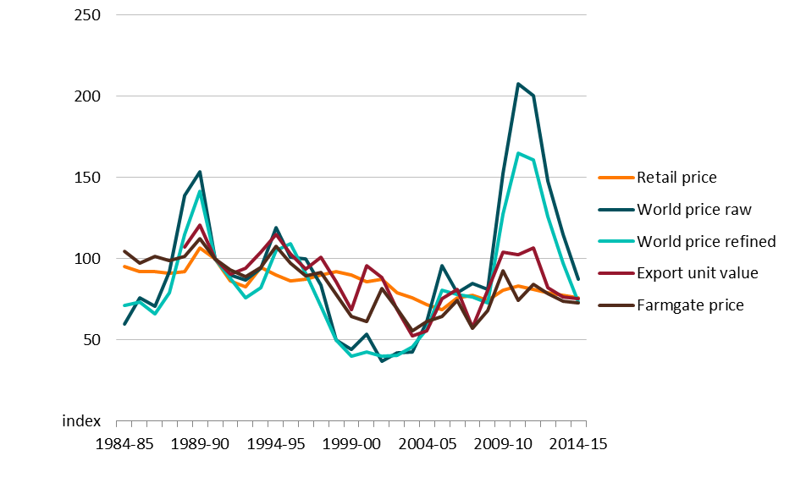

# Farm share and price spread

The aim of this section is to investigate trends in farm share and price spread in the sugar industry. A sharp declining trend in farm share or a widening in price spread could signal inefficiencies in the food supply chain, such as the exercise of market power. A high-level analysis such as this can alert policy makers to the possibility of competition issues in one or more sectors in a supply chain. However, additional analysis would be needed to confirm the existence of imperfect competition because changes in farm share or price spread can occur for a number of reasons that are not related to market power.

## Methodology

The methodology used to estimate farm share and farm-to-retail and farm-to-export price spreads is based on a methodology developed by the USDA ERS (USDA ERS 2016b). This methodology has been applied to farmgate, retail and export price data (described in Chapter 3) to estimate farm share and price spreads in the Australian sugar industry.

The first step in calculating farm share and price spread is to estimate the farm value of a product for each financial year.

Farm value is a measure of the payment farmers receive for the farm product equivalent of the product sold to customers, or stated differently and specific to sugar, the value of sugar cane that has gone into the end product sold to customers. In this analysis, two end products are considered, refined sugar (sold in retail stores) and bulk raw sugar (sold to export markets), so two farm value series are calculated. It is important to note that the export market is much more significant than the retail market in Australia, with only a small proportion of the sugar produced in Australia sold in domestic retail stores.

Farm value is calculated as the gross value of the farm product needed to produce a given retail (or export) product less the value of any co-products. Co-products are other products of value produced during the manufacturing process (for example, molasses is an important co-product of the milling process).

The gross farm value of the export product (bulk raw sugar) for each year equals the local unit value of sugar cane multiplied by the cane to sugar ratio (CSR). The CSR is the amount of sugar cane needed to produce one kilogram of raw sugar. This ratio varies with the quality of sugar cane. Average annual CSRs are obtained from ABARES Agricultural Commodity Statistics. The CSR for the Australian sugar industry averaged 7.24 between 1984–85 and 2014–15 (ABARES 2015).

The gross farm value of the retail product (refined sugar) equals the local unit value of sugar cane multiplied by the CSR (as above) and a conversion factor representing the amount of raw sugar needed to produce one kilogram of refined sugar. This second conversion factor is assumed to be 1.07 (for all years), in line with the value used by the USDA ERS (USDA ERS 2016b).

Net farm value (referred to as farm value in the rest of this paper) is gross farm value less the value of co-products. The USDA ERS (2015) estimates that co-products account for 6 per cent of the farm value of sugar cane. Ideally, the co-products estimate used in this analysis would be based on Australian data. However, this data is not publicly available, so the US estimate has been used. As such, farm value is simply the gross farm value (of either the export or retail product) multiplied by 0.94.

Once the farm values of retail and export products are estimated, farm share and price spread can be easily calculated.

## Farm share of retail price

Farm share of the retail price of sugar averaged 19.3 per cent between 1984–85 and 2014–15 (Figure 4). It was highest in 1988–89, at 23.7 per cent, and lowest in 2000–01, at 13.2 per cent. In 2014–15, it was 18.3 per cent. Figure 4 shows that farm share of the retail price has trended down slightly over the last 30 years. The average year on year decrease is relatively small, at 0.17 percentage points a year. The dip in farm share between the mid 1990s and early 2000s coincided with a significant expansion in Brazilian exports. Between 1994–95 and 2000–01 the world price of raw sugar fell by 55 per cent while the farmgate price of cane fell by 43 per cent.

Figure Farm share of retail price, sugar, 1984–85 to 2014–15

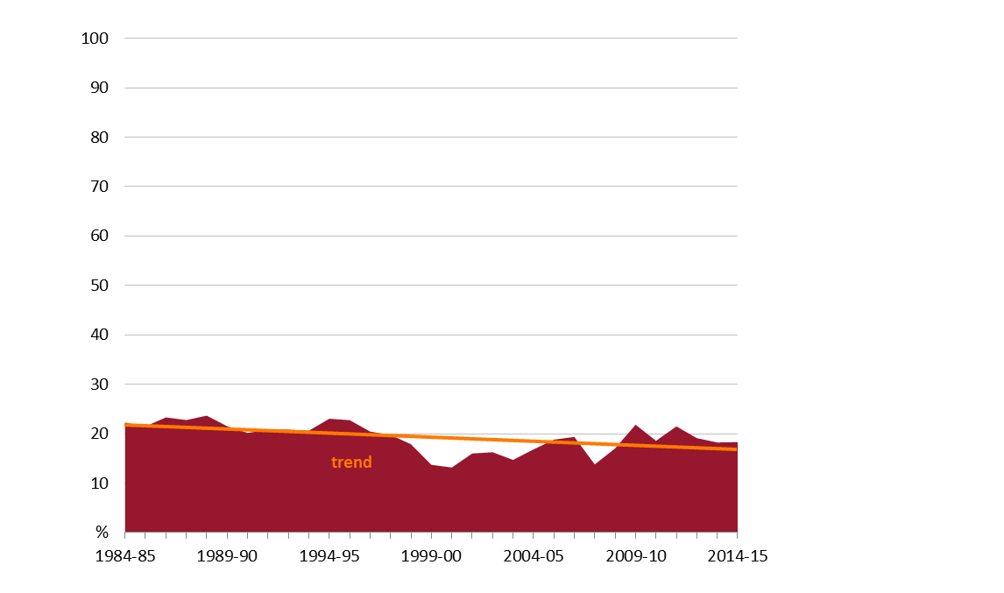

Given that the farm share estimates derived in this study are based on the same methodology used by USDA ERS, it is possible to compare US estimates with Australian farm share estimates (farm share for sugar in the United States is reported in the USDA ERS ‘Price Spreads from Farm to Consumer’ series (USDA ERS 2016b)). In the United States, farm share of the retail price of refined sugar averaged 27.3 per cent between 2000 and 2013, while in Australia it averaged 17.5 per cent between 2000–01 and 2013–14 (note, US estimates are only available by calendar year). Farm share in the United States was quite flat over this period, except for a drop in 2013 when it fell to 21 per cent, its lowest in over a decade. The significant decline in farm value in 2013 coincided with high levels of sugar cane and sugar beet production (USDA ERS 2016b).

One reason why farm share for sugar is higher in the United States than in Australia is because US domestic sugar prices (and cane prices) are maintained above world prices through the US sugar program. This program includes a number of measures to support the domestic industry, including a loans program (which effectively sets a price floor for sugar and sugar cane) and various import restrictions.

## Farm share of export price

Farm share of the export price of raw sugar averaged 56.7 per cent between 1988–89 and 2014–15 (Figure 5). It was at its lowest in 2000–01, when it fell to 36.9 per cent, before increasing to a high of 68 per cent in 2004–05. In 2014–15, it was 57.8 per cent. Similar to farm share of the retail price, farm share of the export price trended down slightly between 1988–89 and 2014–15, declining on average by 0.26 percentage points a year. One factor that is likely to have contributed to the sharp decline in farm share in 2000–01 and 2010–11 was extreme weather, which reduced the quality and quantity of sugar cane.

Figure Farm share of export price, sugar, 1988–89 to 2014–15

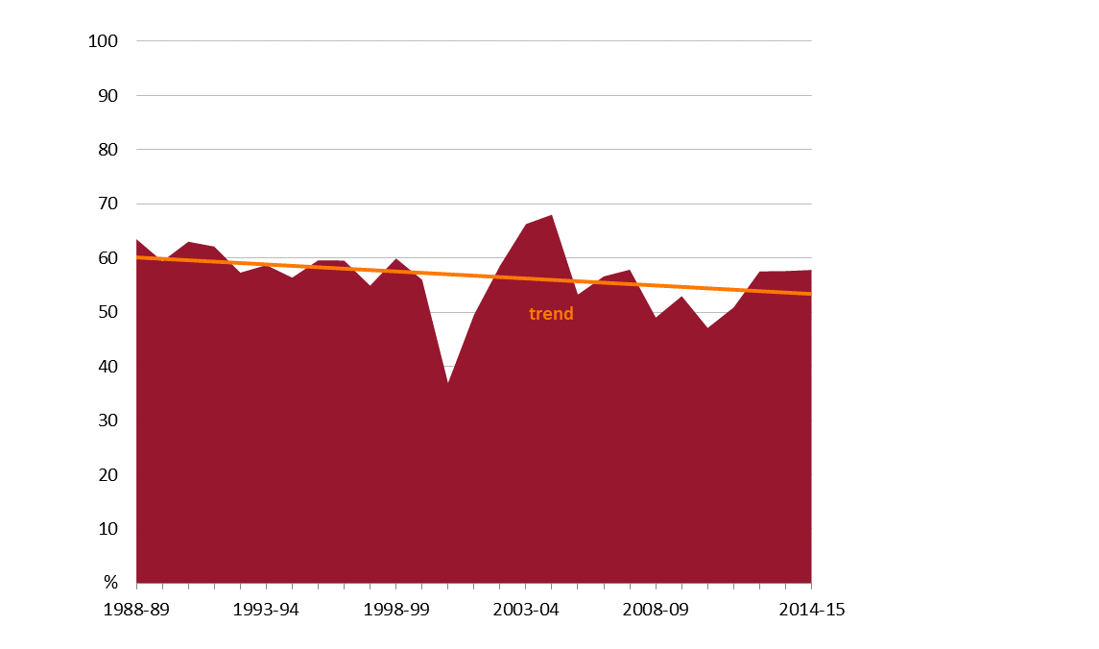

## Comments on farm share

It is often difficult to explain short-term movements in farm share because farm share can change year on year for many reasons. For example, the farm share statistic is very sensitive to the price data used, and unpacking why price series have moved differently in any particular year can be difficult because of various data issues described earlier (for example, high levels of aggregation and differences in futures and spot markets).

Despite the limitations with the farmgate and export price data used in this analysis, longer term trends in these prices and farm share should remain valid. As mentioned previously, a sustained decrease in farm share over time could indicate imperfect price transmission, and the existence of market power in the value chain. However, it could also be because of other factors such as differences in productivity in different sectors. For example, if the cost of producing sugar cane decreases relative to the cost of producing the retail product (which could include transport, processing and retailing), this is likely to be reflected in a decline in farm share.

For Australia, the initial findings of this analysis show that farm shares of retail and export prices have remained relatively stable, only trending down slightly since the 1980s. Figure 4 actually suggests that there has been a slight upward trend in farm share of the retail price since the early 2000s. It may be worthwhile updating this analysis in a few years time to see if recent changes in raw sugar marketing arrangements have any impact on the trend in farm share.

It is also reasonable to expect farm share of the retail price of sugar to be lower than farm share for some other less processed food products (more highly processed foods typically receiving a lower farm share), and to be lower than in the United States, where farm share is influenced by measures designed to support the domestic industry.

## Farm-to-retail price spread

The price spread (or the marketing bills) between farm value and the retail value for sugar averaged 136.4 cents a kilogram between 1984–85 and 2014–15 (Figure 6). It was highest in 1989–90, at 166.3 cents a kilogram, and lowest in 2005–06, at 110.4 cents a kilogram. In 2014–15, the spread was 123.5 cents a kilogram, lower than the average for this period. Figure 6 shows a slight downward trend in price spread (that is, a narrowing in spread) over the past 30 years.

The increase in price spread between the mid 1990s and early 2000s coincided with declining world prices.

Figure Farm-to-retail price spread, sugar, 1984–85 to 2014–15

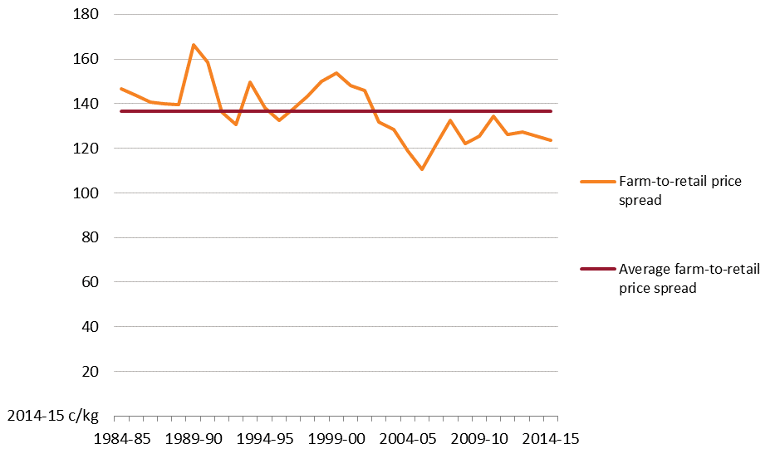

## Farm-to-export price spread

The price spread between farm value and the export unit value of raw sugar averaged 22.9 cents a kilogram between 1988–89 and 2014–15 (Figure 7). The spread was highest in 2000–01, at 35.9 cents a kilogram, and lowest in 2003–04, at 10.5 cents a kilogram. In 2014–15, it was 18.9 cents a kilogram, lower than the average for this period. There is no obvious long-term trend in the spread.

Figure Farm-to-export price spread, sugar, 1988–89 to 2014–15

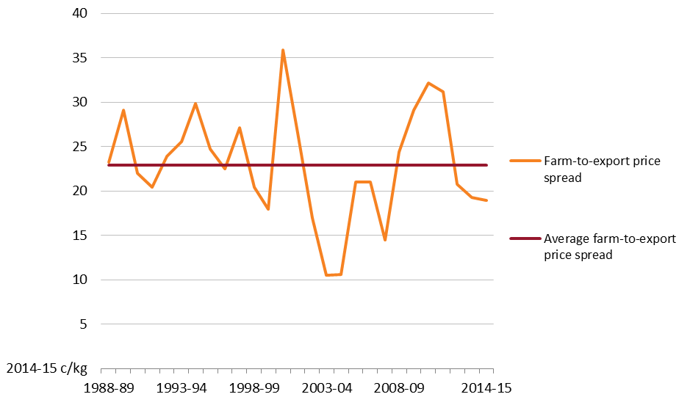

The farm-to-export price spread peaked twice over this period, first in 2000–01, and again in 2010–11. Real local unit values for cane fell in both years while export unit values were relatively high. It is likely that extreme weather contributed to the widening in spread in these years.

## Comments on price spreads

Farm-to-retail and farm-to-export price spreads capture the cost of services beyond the farm gate needed to transform raw products into the saleable products (in this analysis raw sugar for export or refined sugar for retail sale), plus profit margins. For raw sugar, the price spread includes transport, milling, storage and export costs, while for refined sugar, refining and retailing costs are also included. Apart from imperfect competition, an increase in price spread may be a legitimate reflection of changes within the industry. For example, price spread may increase or decrease over time as the price and mix of inputs and services required to transform farm products into consumer products changes (Nguyen, Mobsby & Goesch 2016).

Similar to movements in farm share, Figures 6 and 7 show significant short-term movements in farm-to-retail and farm-to-export price spreads for sugar. However, these figures do not indicate any persistent widening in price spreads over the past 25 to 30 years, with the overall trends appearing to be relatively flat, and to even decline slightly in the retail sector.

## Further research

There are several options that could improve the analysis undertaken in this study. To begin with, it may be possible to breakdown some of the costs beyond the farm gate through industry consultation. However, much of this data is likely to be commercially sensitive. This approach is also likely to be more expensive than the relatively simple high level analysis undertaken in this study. It may also be possible to improve the accuracy of farm share and price spread estimates through the use of retail scanner data from supermarkets or homescan data from market research companies given that the ABS no longer publish data on retail prices for sugar. The ABS 'Other food' subgroup price series used in this study as a proxy for retail sugar prices since September 2011 includes a range of foods. While this subgroup includes sugar and a number of food items that are likely to have a high sugar content, it also includes foods that contain little or no refined sugar. It is worth noting that companies supplying retail scanner or homescan data may impose restrictions on its use given the proprietary nature of the data.

References

ABARE 2007, Australian commodities: March quarter 2007, Australian Bureau of Agricultural and Resource Economics, Canberra, available at [agriculture.gov.au/abares/publications/](http://www.agriculture.gov.au/abares/publications/).

—— 2006, Australian commodities: March quarter 2006, Australian Bureau of Agricultural and Resource Economics, Canberra, available at [agriculture.gov.au/abares/publications/](http://www.agriculture.gov.au/abares/publications/).

—— 2003, Australian commodities statistics 2002, Australian Bureau of Agricultural and Resource Economics, Canberra, available at [agriculture.gov.au/abares/publications/](http://www.agriculture.gov.au/abares/publications/).

ABARES 2016, Agricultural commodities: September quarter 2016, Australian Bureau of Agricultural and Resource Economics and Sciences, Canberra, available at [agriculture.gov.au/abares/publications/](http://www.agriculture.gov.au/abares/publications/).

—— 2015, Agricultural commodity statistics 2015, Australian Bureau of Agricultural and Resource Economics and Sciences, Canberra, available at [agriculture.gov.au/abares/publications/](http://www.agriculture.gov.au/abares/publications/).

ABS 2015, International Trade, Australia, cat. no. 5465.0, Australian Bureau of Statistics, Canberra, available at [abs.gov.au/AUSSTATS/abs@.nsf/productsbyCatalogue/E0E5015B73608361CA25756D0013AF9F?OpenDocument](mailto:abs.gov.au/AUSSTATS/abs@.nsf/productsbyCatalogue/E0E5015B73608361CA25756D0013AF9F?OpenDocument).

—— 2011a, Average Retail Prices of Selected Items, Eight Capital Cities, cat. no. 6403.0 and 6403.0.55.001, Australian Bureau of Statistics, Canberra, available at [abs.gov.au/ausstats/abs@.nsf/mf/6403.0.55.001](mailto:abs.gov.au/ausstats/abs@.nsf/mf/6403.0.55.001).

—— 2011b, Consumer Price Index: Concepts, Sources and Methods, 2011, cat. no. 6461.0, [abs.gov.au/AUSSTATS/abs@.nsf/Lookup/6461.0Appendix12011](mailto:abs.gov.au/AUSSTATS/abs@.nsf/Lookup/6461.0Appendix12011).

Albertson, P & Grof, C 2004, ‘The Effect of Hexose upon pol, brix and calculated CCS in sugar cane: A potential for negative pol bias in juice from actively growing cane’, Journal American Society Sugar Cane Technologists, vol. 24, pp. 185-198, available at [assct.org/journal/JASSCT%20PDF%20Files/volume%2024/M03-03%20Albertson%20final.pdf](http://www.assct.org/journal/JASSCT%20PDF%20Files/volume%2024/M03-03%20Albertson%20final.pdf) (pdf 377.1kb).

ASMC 2015a, Submission to the Queensland Parliament Agriculture and Environment Committee's examination of the Sugar Industry (Real Choice in Marketing) Amendment Bill 2015, Australian Sugar Milling Council, July, available at [asmc.com.au/wp-content/uploads/2013/08/AEC-Combined-Submission.pdf](http://asmc.com.au/wp-content/uploads/2013/08/AEC-Combined-Submission.pdf) (pdf 1.67mb).

—— 2015b, ‘Australian Sugarcane Industry Overview’, Australian Sugar Milling Council, available at [asmc.com.au/industry-overview/](http://asmc.com.au/industry-overview/).

—— 2015c, Cane railways in the Sugar Industry, Australian Sugar Milling Council, available at [asmc.com.au/industry-overview/fact-sheets/](http://asmc.com.au/industry-overview/fact-sheets/).

—— 2015d, Submission to the Queensland Productivity Commission's regulatory impact assessment of the Sugar Industry (Real Choice in Marketing) Amendment Bill 2015, Australian Sugar Milling Council, October, available at [qpc.qld.gov.au/files/uploads/2015/10/Australian-Sugar-Milling-Council-Submission.pdf](http://qpc.qld.gov.au/files/uploads/2015/10/Australian-Sugar-Milling-Council-Submission.pdf) (pdf 552.3kb).

—— 2014, Submission to the Senate Standing Committee on Rural and Regional Affairs and Transport Inquiry into Current and future arrangements for the marketing of Australian sugar, Australian Sugar Milling Council, October, available at [aph.gov.au/Parliamentary_Business/Committees/Senate/Rural_and_Regional_Affairs_and_Transport/Sugar/Submissions](http://www.aph.gov.au/Parliamentary_Business/Committees/Senate/Rural_and_Regional_Affairs_and_Transport/Sugar/Submissions).

BITRE 2015, Freightline 3 - Australian sugar freight transport, Bureau of Infrastructure, Transport and Regional Economics, Canberra, available at [bitre.gov.au/publications/index.aspx](http://bitre.gov.au/publications/index.aspx).

Breguet, P 2011, ‘Assessing the future of the Australian sugar industry’, Queensland Sugar Limited, available at [qsl.com.au/sites/default/files/QSL%20FO%20Licht%20presentation%20China%20Sept%202011.pdf](http://www.qsl.com.au/sites/default/files/QSL%20FO%20Licht%20presentation%20China%20Sept%202011.pdf) (1.62mb).

Butcher, K 2012, Futures made Simple: The essential guide to trading futures, without all the fuss, John Wiley & Sons, New Jersey.

Canegrowers 2010, ‘Statistics facts & figures’, Canegrowers, available at [canegrowers.com.au/page/Industry_Centre/About_Us/statistics-facts-figures/](http://www.canegrowers.com.au/page/Industry_Centre/About_Us/statistics-facts-figures/).

Canegrowers & ACFA 2015, Submission to the Queensland Productivity Commission's regulatory impact assessment of the Sugar Industry (Real Choice in Marketing) Amendment Bill 2015, Canegrowers & Australian Cane Farmers Association, October, available at [qpc.qld.gov.au/files/uploads/2015/10/Canegrowers-and-Australian-Cane-Farmers-Association-Joint-Submission.pdf](http://qpc.qld.gov.au/files/uploads/2015/10/Canegrowers-and-Australian-Cane-Farmers-Association-Joint-Submission.pdf) (pdf 2.2mb).

Goesch, T, Lawson, K, Green, R & Morey, K 2015, Australia’s beef supply chains: infrastructure issues and implications, ABARES research report 15.7, Canberra, October.

Hannah, A & Spence, D 1997, The International Sugar Trade, John Wiley & Sons Inc., New York.

ICE Futures U.S. 2012, Sugar No. 11 and Sugar No. 16, Intercontinental Exchange Inc., US, available at [theice.com/publicdocs/ICE_Sugar_Brochure.pdf](https://www.theice.com/publicdocs/ICE_Sugar_Brochure.pdf) (pdf 1.18mb).

Industry Commission 1992, The Australian Sugar Industry: Report No. 19, Commonwealth of Australia, Canberra, available at [pc.gov.au/inquiries/completed/sugar/19sugar.pdf](http://www.pc.gov.au/inquiries/completed/sugar/19sugar.pdf) (pdf 1.43mb).

New York Board of Trade 2006, Sugar: Futures & Options, New York Board of Trade, New York, available at [gofutures.com/pdfs/sugar-futures-options.pdf](http://gofutures.com/pdfs/sugar-futures-options.pdf) (pdf 4.59mb).

Nguyen, N, Mobsby, D & Goesch, T 2016, Farm share and price spread in food supply chains: background paper, Australian Bureau of Agricultural and Resource Economics and Sciences, Canberra.

Productivity Commission 2016, Regulation of Australian Agriculture, Report No. 79, Canberra, November, available at [pc.gov.au/inquiries/completed/agriculture/report/agriculture.pdf](http://www.pc.gov.au/inquiries/completed/agriculture/report/agriculture.pdf) (pdf 6.85mb).

Queensland Productivity Commission 2015, Decision Regulatory Impact Statement: Sugar Industry (Real Choice in Marketing) Amendment Bill 2015, November, available at [qpc.qld.gov.au/files/uploads/2015/11/Sugar-RIS-FINAL.pdf](http://qpc.qld.gov.au/files/uploads/2015/11/Sugar-RIS-FINAL.pdf) (pdf 2.88mb).

QSL 2016, QSL RSSA Marketing Guide: 2016 Season Edition, Queensland Sugar Limited, Brisbane.

—— 2015a, QSL: Working for YOU: Annual Report 2014/15, Queensland Sugar Limited, Brisbane, available at [qsl.com.au/media-publications/annual-reports](http://www.qsl.com.au/media-publications/annual-reports).

—— 2015b, QSL Shared Pool: An Overview - 2016 Season, Queensland Sugar Limited, Brisbane, available at [qsl.com.au/sites/default/files/2016%20Shared%20Pool.pdf](http://www.qsl.com.au/sites/default/files/2016%20Shared%20Pool.pdf) (pdf 54.4kb).

—— 2013, QSL RSSA Marketing Guide: 2013 Season Edition, Queensland Sugar Limited, Brisbane, available at [qsl.com.au/sites/default/files/QSL%20RSSA%20Marketing%20Guide.pdf](http://www.qsl.com.au/sites/default/files/QSL%20RSSA%20Marketing%20Guide.pdf) (pdf 713.3kb).

Queensland Transport and Logistics Council 2014, Supply Chain Perspectives: Sugar, Queensland Transport and Logistics Council, available at [qtlc.com.au/](http://www.qtlc.com.au/).

Sunshine Sugar 2015, Manildra Harwood Sugars, Sunshine Sugar, available at [nswsugar.com.au/](http://nswsugar.com.au/).

Spencer, S 2004, Price Determination in the Australian Food Industry, A report, Australian Government Department of Agriculture, Fisheries and Forestry, Canberra.

Trade & Investment Queensland Australia 2015, Korea-Australia Free Trade Agreement, Queensland Government, available at [tiq.qld.gov.au/wp-content/uploads/2015/08/TIQ-782-14-KAFTA-flyer-EndOpps.pdf](http://tiq.qld.gov.au/wp-content/uploads/2015/08/TIQ-782-14-KAFTA-flyer-EndOpps.pdf) (pdf 443.4kb).

USDA ERS 2016a, ‘Sugar and Sweeteners Yearbook Tables’, United States Department of Agriculture Economic Research Service, available at [ers.usda.gov/data-products/sugar-and-sweeteners-yearbook-tables.aspx](http://www.ers.usda.gov/data-products/sugar-and-sweeteners-yearbook-tables.aspx)

—— 2016b, Price spreads from farm to consumer, United States Department of Agriculture Economic Research Service, available at [ers.usda.gov/data-products/price-spreads-from-farm-to-consumer.aspx](https://www.ers.usda.gov/data-products/price-spreads-from-farm-to-consumer.aspx).

—— 2015, Documentation: How ERS Calculates Farm Share for Individual Foods, United States Department of Agriculture Economic Research Service, available at [ers.usda.gov/data-products/price-spreads-from-farm-to-consumer/documentation/#Conversion](https://www.ers.usda.gov/data-products/price-spreads-from-farm-to-consumer/documentation/#Conversion).

Valle, H & Martin, P 2015, Australian sugar cane farm businesses: Financial performance, 2013–14, Australian Bureau of Agricultural and Resource Economics and Sciences, Canberra.

Wilmar Sugar 2014, Submission to the Senate Standing Committee on Rural and Regional Affairs and Transport Inquiry into Current and future arrangements for the marketing of Australian sugar, Wilmar Sugar Australia Limited, October, available at [aph.gov.au/Parliamentary_Business/Committees/Senate/Rural_and_Regional_Affairs_and_Transport/Sugar/Submissions](http://www.aph.gov.au/Parliamentary_Business/Committees/Senate/Rural_and_Regional_Affairs_and_Transport/Sugar/Submissions).